**Coding Challenge-1**

Name: Harish Er

**DATABASE:**

**Customers:**

**CREATE TABLE Customers (**

**CustomerID INT PRIMARY KEY,**

**CustomerName NVARCHAR(100),**

**City NVARCHAR(50)**

**);**

**INSERT INTO Customers (CustomerID, CustomerName, City) VALUES**

**(1, 'Amit Sharma', 'Mumbai'),**

**(2, 'Priya Singh', 'Delhi'),**

**(3, 'Ravi Kumar', 'Bangalore'),**

**(4, 'Anita Desai', 'Chennai'),**

**(5, 'Sunil Verma', 'Hyderabad'),**

**(6, 'Pooja Patel', 'Pune'),**

**(7, 'Rakesh Mehta', 'Ahmedabad'),**

**(8, 'Sita Iyer', 'Kolkata'),**

**(9, 'Vikram Malhotra', 'Mumbai'),**

**(10, 'Kavita Rao', 'Jaipur');**

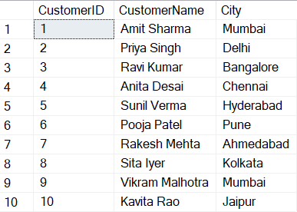

**Orders:**

**CREATE TABLE Orders (**

**OrderID INT PRIMARY KEY,**

**CustomerID INT,**

**OrderDate DATE,**

**TotalAmount DECIMAL(10, 2),**

**FOREIGN KEY (CustomerID) REFERENCES Customers(CustomerID)**

**);**

**INSERT INTO Orders (OrderID, CustomerID, OrderDate, TotalAmount) VALUES**

**(201, 1, '2024-01-05', 500.00),**

**(202, 2, '2024-01-10', 750.00),**

**(203, 3, '2024-02-15', 1200.00),**

**(204, 4, '2024-02-20', 600.00),**

**(205, 5, '2024-03-25', 450.00),**

**(206, 6, '2024-04-01', 800.00),**

**(207, 7, '2024-05-10', 1300.00),**

**(208, 8, '2024-06-15', 400.00),**

**(209, 9, '2024-07-20', 900.00),**

**(210, 10, '2024-08-25', 1100.00);**

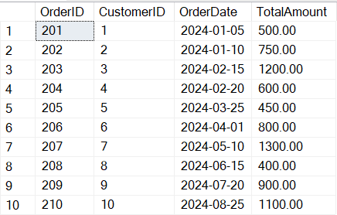

**Couriers:**

**CREATE TABLE Couriers (**

**CourierID INT PRIMARY KEY,**

**CourierName NVARCHAR(100),**

**City NVARCHAR(50)**

**);**

**INSERT INTO Couriers (CourierID, CourierName, City) VALUES**

**(1, 'Rajesh Express', 'Mumbai'),**

**(2, 'QuickGo', 'Delhi'),**

**(3, 'Swift Couriers', 'Bangalore'),**

**(4, 'Speedy Deliveries', 'Chennai'),**

**(5, 'RapidMove', 'Hyderabad'),**

**(6, 'DeliverNow', 'Pune'),**

**(7, 'Express India', 'Ahmedabad'),**

**(8, 'FastTrack', 'Kolkata'),**

**(9, 'SafeHand', 'Mumbai'),**

**(10, 'OneDay Delivery', 'Jaipur');**

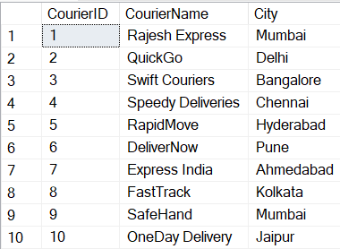

**Deliveries:**

**CREATE TABLE Deliveries (**

**DeliveryID INT PRIMARY KEY,**

**OrderID INT,**

**CourierID INT,**

**DeliveryDate DATE,**

**Status NVARCHAR(50),**

**FOREIGN KEY (OrderID) REFERENCES Orders(OrderID),**

**FOREIGN KEY (CourierID) REFERENCES Couriers(CourierID)**

**);**

**INSERT INTO Deliveries (DeliveryID, OrderID, CourierID, DeliveryDate, Status) VALUES**

**(301, 201, 1, '2024-01-06', 'Delivered'),**

**(302, 202, 2, '2024-01-11', 'In Transit'),**

**(303, 203, 3, '2024-02-16', 'Delivered'),**

**(304, 204, 4, '2024-02-21', 'Pending'),**

**(305, 205, 5, '2024-03-26', 'Delivered'),**

**(306, 206, 6, '2024-04-02', 'In Transit'),**

**(307, 207, 7, '2024-05-11', 'Delivered'),**

**(308, 208, 8, '2024-06-16', 'Pending'),**

**(309, 209, 9, '2024-07-21', 'Delivered'),**

**(310, 210, 10, '2024-08-26', 'In Transit');**

